**7805 Voltage Regulator**

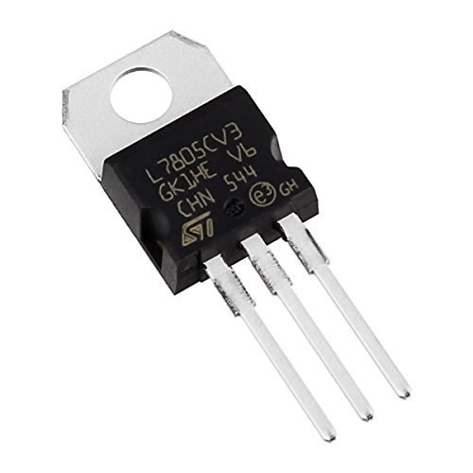

7805 is a three terminal linear voltage regulator IC with a fixed output voltage of 5V which is useful in a wide range of applications. Currently, the 7805 Voltage Regulator IC is manufactured by Texas Instruments, ON Semiconductor, STMicroelectronics, Diodes incorporated, Infineon Technologies, etc.

They are available in several IC Packages like TO-220, SOT-223, TO-263 and TO-3. Out of these, the TO-220 Package is the most commonly used one (it is the one shown in the above image).

Some of the important features of the 7805 IC are as follows:

* It can deliver up to 1.5 A of current (with heat sink).
* Has both internal current limiting and thermal shutdown features.
* Requires very minimum external components to fully function.

### Pin Diagram of 7805 Voltage Regulator IC

As mentioned earlier, 7805 is a three terminal device with the three pins being 1. INPUT, 2. GROUND and 3. OUTPUT. The following image shows the pins on a typical 7805 IC in To-220 Package.

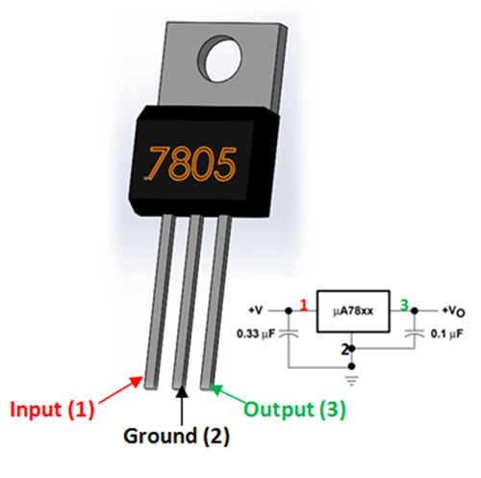

The pin description of the 7805 is described in the following table:

| **PIN NO.** | **PIN** | **DESCRIPTION** |
| --- | --- | --- |
| 1 | INPUT | Pin 1 is the INPUT Pin. A positive unregulated voltage is given as input to this pin. |
| 2 | GROUND | Pin 2 is the GROUND Pin. It is common to both Input and Output. |
| 3 | OUTPUT | Pin 3 is the OUTPUT Pin. The output regulated 5V is taken at this pin of the IC. |

### Basic Circuit of 7805

As I have previously talked about regulated power supply as a device that works on DC voltages and it can uphold its output accurately at a fixed voltage all the time even if there is a significant alteration in the DC input voltage.

As per the datasheets of 7805 IC, the basic circuit required for 7805 to work as a complete regulator is very simple. In fact, if the input supply is an unregulated DC Voltage, then all you need are two capacitor (even those are not mandatory depending on the implementation).

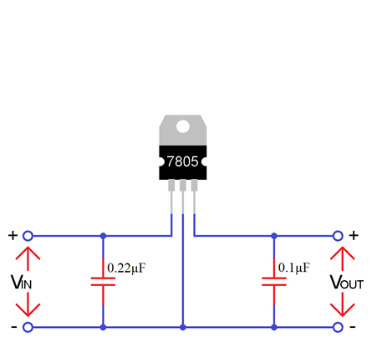

The above circuit shows all the components required for a 7805 IC to work properly. The 0.22μF Capacitor near the input is required only if the distance between the regulator IC and the power supply filter is high. Also, the 0.1μF Capacitor near the output is optional and if used, it helps in the transient response.

In this circuit, VIN is the input voltage to the 7805 IC and the source can be from either a battery of an unregulated DC. VOUT is the output of the 7805 IC, which is a Regulated 5V.

**7805 Regulator Features**

* 5V Positive Voltage Regulator
* Minimum Input Voltage is 7V
* Maximum Input Voltage is 25V
* Operating current(IQ) is 5mA
* Internal Thermal Overload and Short circuit current limiting protection is available.
* Junction Temperature maximum 125 degree Celsius
* Available in TO-220 and KTE package